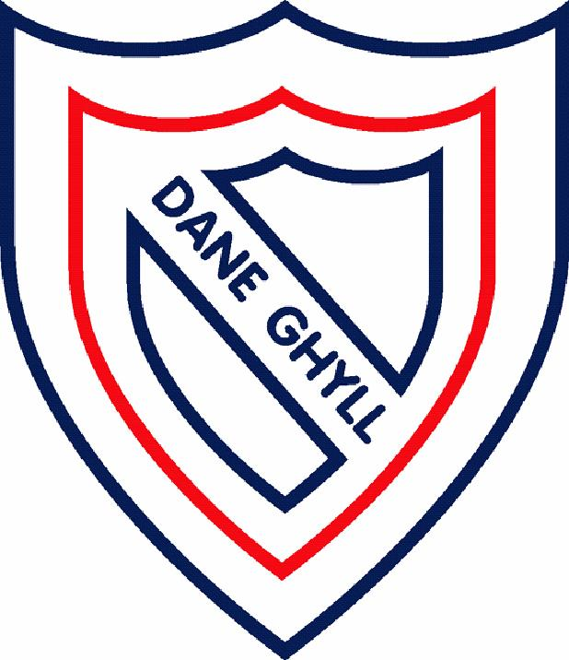
RE

Religious Education is not a statutory part of the National Curriculum and as such all state-funded, local authority schools must provide a basic curriculum. Schools designated as having a religious character are free to make their own decisions in preparing their syllabuses. ‘The curriculum for a maintained school must be a balanced and broadly based one which ‘promotes the spiritual, moral, cultural, mental and physical development of pupils and of society, and prepares pupils for the opportunities, responsibilities and experiences of later life’.’ Section 2 79 (1) School Standards and Framework Act.
► RE should provide opportunities for pupils to develop positive attitudes and values and to reflect and relate their learning in RE to their own experience.
► Building on the statutory requirements, it is recommended that there should be a wide- ranging study of religion and belief across the key stages as a whole.
► Not all religions need to be studied at the same depth or in each key stage, but all that are studied should be studied in a way that is coherent and promotes progression.
► Pupils should have the opportunity to learn that there are those who do not hold religious beliefs and have their own philosophical perspectives, and subject matter should facilitate integration and promotion of shared values.
► The study of religion should be based on the legal requirements and provide an appropriate balance between and within Christianity, other principal religions and, where appropriate, other religious traditions and worldviews, across the key stages as a whole, making appropriate links with other parts of the curriculum and its cross-curricular dimensions.

These three areas underpin the breadth of coverage of RE in Dane Ghyll Community Primary School:
► SMSC

►Personal Growth and Development
►Community Cohesion

To gain a better understanding of various religions, we also study the following

► Beliefs and teachings (from various religions)
Understanding the key teachings of various religions.

► Rituals, ceremonies and lifestyles (from various religions)
Exploring the day-to-day lives and practices of various religions.

► Time to reflect and personal growth
Showing an appreciation for how religion plays an important role in people’s lives. Exploring identity and who we are.

► How beliefs are expressed
Understanding how books, scriptures, symbols, art and readings convey beliefs.

The RE coverage at Dane Ghyll Community Primary School aims to:
► provoke challenging questions; ► teach pupils to develop respect for others;

► encourage pupils to explore their own beliefs; ► prompt pupils to consider their responsibilities.

► enable pupils to build their sense of identity and belonging;

Implementation
We offer a broad range of study for children studying RE. Through the teaching of RE, children at Dane Ghyll Community Primary School learn about six different religions / worship. The emphasis is on personal growth and community cohesion, whilst allowing for personal development for the children from KS1 to the end of KS2.

Impact
Children will have a better understanding of the religions that make up the UK landscape and how they can learn from and work alongside each other to create community cohesion. All children will be more informed about their position in the world, and the decisions they can make impacting their future. All children in Dane Ghyll Community Primary School will be able to talk confidently about their wellbeing, moral and cultural development for the society in which they live. The RE curriculum will promote inquisitive minds, respect, tolerance and understanding for all those around them including themselves. Lessons enable high quality work to be produced and evidenced, showcasing a deep understanding of the main religions of the world, their community and their future. Evidence will be seen through using the correct vocabulary, explanations and respectful opinions, as well as cross-curricular evidence, for example religious and cultural art work, drama, craft and presentations.

